Assessment Schedule – 2016

Biology: Demonstrate understanding of life processes at the cellular level (91156)

Assessment Criteria
Achievement | Achievement with Merit | Achievement with Excellence
Demonstrate understanding involves defining, using annotated diagrams or models to describe, and describing characteristics of, or providing an account of, life processes at the cellular level. | Demonstrate in-depth understanding involves using biological ideas to give reasons how or why life processes occur at the cellular level. | Demonstrate comprehensive understanding involves linking biological ideas about life processes at the cellular level. The discussion of ideas may involve justifying, relating, evaluating, comparing and contrasting, analysing.
Evidence
ONE | Expected Coverage | Achievement | Merit | Excellence
(a) | 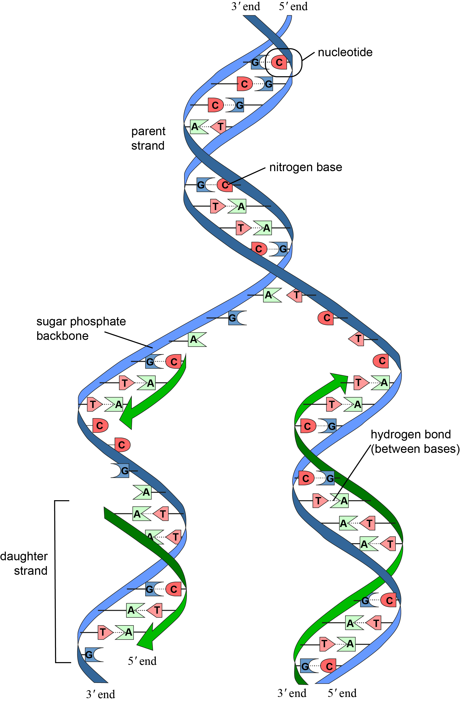 | - Correctly labels 5 of nitrogen base, nucleotide, hydrogen bond, parent strand, daughter strand, or sugar-phosphate backbone.
(b) | The purpose of DNA replication is to replicate the cells’ DNA in preparation for cell division. Replicated DNA is passed on to daughter cells, ensuring the new daughter cells carry out the same function as parent cells. | - Describes the purpose of DNA replication.  The purpose of DNA replication is to produce new copies of DNA | - Identical copies of DNA are needed for new cells produced during cell division / Mitosis so these cells can carry out the same function as the parent / original cells
(c) | The structure of an enzyme is composed of a protein and possible non-protein called a co-factor. It has an active site, which joins or breaks substrate / a 3D protein folded and joined to other proteins by hydrogen and sulphide bonds to form an active site which the substrate binds to.  Enzymes’ function is to catalyse or speed up biological reactions by lowering activation energy. They are specific to a reaction and are not used up in the reaction.  Enzymes are involved in each step of DNA replication. During DNA replication, a specific enzyme unwinds the DNA helix exposing nucleotides. Another enzyme synthesises the new DNA strands by adding complementary nucleotides to the template strands.  During DNA replication, enzymes function using the induced fit model. The active site and substrate are not initially perfect matches for each other. The active site continues to change until the substrate is completely bound to it, at which point the final shape of the enzyme is determined.  Factors that affect enzymes during DNA replication include temperature, pH, substrate concentration, co-factors, enzyme concentration, and poisons.  Temperature – all enzymes have an optimum temperature. At very low temperatures, enzyme action slows, and at high temperatures the 3D shape may change and denature. Denaturing is irreversible and means the enzyme is inactive.  Substrate – an increase in substrate concentration means more can combine with enzymes’ active site and therefore increase the rate of reaction until the available enzyme molecules become ‘saturated’ and the rate of reaction levels off (may use an annotated diagram to show this).  pH – enzymes have an optimum pH range. Outside their optimum range can cause an enzyme’s active site to denature, preventing substrates from binding.  High enzyme concentration allows for increased rate of reaction.  Co-enzyme – alter the shape of the active site in such a way that it can effectively combine with substrates. A decrease in co-factor would reduce the rate of reaction or even stop the enzyme.  Inhibitors – are poisons that alter or block the active site, preventing substrates from binding.  Enzymes are involved in each step of DNA replication, and therefore the rate of DNA replication is dependent on factors affecting enzyme action. Therefore these factors would also affect growth, repair and meiosis / mitosis / cell division. | - Describes the structure of an enzyme. (Labelled diagram acceptable.)  - Describes the function of enzymes.  - Describes one factor that affects enzyme.  Temperature / pH / Concentration of Enzyme / Concentration of Substrate. Cofactors / Inhibitors or Poisons.  Names of specific enzymes not required. | - Explains how enzymes function (in DNA replication).  The active site of an enzyme attaches to a substrate and speeds up biological reactions by lowering the activation energy needed. Such reactions include the unwinding of the DNA helix to expose nucleotides / such reactions include the synthesis of a new DNA strands that are complementary to the original strands.  OR  Enzymes are specific to a particular reaction and speed up the reaction by lowering the activation energy needed. Such reactions include the unwinding of the DNA helix to expose nucleotides / such reactions include the synthesis of a new DNA strands that are complementary to the original strands.  - Explains how temperature affects enzymes.  - Explains how pH affects enzymes.  - Explains how substrate / enzyme concentration affects enzymes.  - Explains how co-factors affect enzymes.  - Explains how poisons affect enzymes.  Names of specific enzymes not required. | - A discussion that links TWO factors in detail that affect enzymes during DNA replication. (2 linked ‘M’ points.)  - Discusses the consequences of these factors on DNA replication.  This point is the ‘big picture’ DNA replication occurs most efficiently when all the relevant factors are at their optimum value / level. Small deviations from optimums may result in small changes in the rate or efficiency of DNA replication. One factor such as the presence of an inhibitor may have a very significant effect on the process and be the limiting factor despite other factors being at their optimum values / levels. Failure of DNA to replicate fast enough or at all will slow or stop the process of Mitosis occurring. Growth and repair of an organism may be seriously affected resulting in eventual death.  Names of specific enzymes not required.

NØ | N1 | N2 | A3 | A4 | M5 | M6 | E7 | E8
No response; no relevant evidence. | Describes any ONE statement from Achievement. | Describes any TWO statements from Achievement. | Describes any THREE statements from Achievement. | Describes any FOUR statements from Achievement. | Explains any THREE statements from Merit. | Explains any FOUR statements from Merit. | Provides the criteria for Excellence for bullet point 1. | Provides the criteria for Excellence for bullet point 2.

TWO | Expected Coverage | Achievement | Merit | Excellence
(a) | Chromosomes (randomly) align on the cell’s equator / middle. Spindle fibres attach to the chromosomes. | - Describes what is occurring the diagram.  - Describes what is occurring the diagram.  Any one of these statements:  - chromosomes / chromatids are in the middle of the cell  - chromosomes / chromatids are on the equator of the cell  - chromosomes / chromatids are on the spindle / microtubules. |  | - Through discussion, makes links between  SA : V, diffusion, and movement of materials.  Diffusion occurs across a cell membrane and also within the volume of the cell. As SA increases so does the rate of diffusion across the membrane. As there are more sites for this to occur. However as Volume increases the rate of penetration of materials into a cell decreases as the volume increases proportionately more than the Surface Area As the diffusion of materials in and out of the cell decreases the cell becomes deficient in needed materials and overloaded with wastes.
(b) | Mitotic cell division – is the process in which a parent cell divides into two daughter cells. It occurs in somatic / body cells as part of the cell cycle. The daughter cells are identical to the parent cell. Cells divide for growth and repair as well as to maintain large surface area to volume ratio. | - Describes the purpose of mitosis.  Mitosis provides new identical / copies of cells for the growth and repair of somatic / normal body / non- sex / autosomal cells. | - Explains the purpose of cell division.  Cell division increases the efficiency of transport of materials in and out of the cell by increasing the SA:V.
(c) | As a cell grows larger, the volume increases more than the surface area /  SA : V decreases as the cell grows.  Diffusion is the net movement of a substance from high concentration to low concentration. Diffusion takes place along a concentration gradient. A concentration gradient exists until the diffused substance is evenly distributed. Diffusion is passive / has no energy requirement.  As the cell grows larger, SA : V decreases. The cell membrane controls the entry and exit of materials into a cell. Diffusion takes place at the cell membrane; therefore a decrease in surface area would decrease the movement of materials into and out of the cell. Diffusion also occurs within the cell, and if a cell’s volume grows too large, the transport of substances within the cell will be inefficient.  Hence, cells divide to keep high SA : V. | - Describe how SA : V changes as the cell grows.  As a cell grows, the SA:V ratio decreases.  - Describes how SA : V affects movement of materials.  When SA:V decreases the transport of materials slows down / becomes less efficient.  - Diffusion is a Passive process of movement.  - Diffusion is movement from high to low concentration. | - Explains diffusion.  Diffusion is the passive movement of materials along a concentration gradient from an area of higher concentration to an area of lower concentration.  - Explains how SA : V affects movement of materials into and out of a cell.  As SA increases, the sites of entry and exit through the cell membrane increase, making diffusion more rapid. As volume increases, the distance materials need to travel to penetrate the cell gets greater. The proportionate increase in SA compared to V is less as a cell grows.  - Explains how SA : V affects diffusion efficiency.  The proportionate increase in SA compared to V is less as a cell grows. For this reason efficiency drops.  - Explains how SA : V affects cell division.  As SA:V decreases the cell will become deficient in essential materials such as oxygen, energy and overloaded with wastes such as carbon dioxide. This will trigger the process of cell division (mitosis). | - Through discussion, makes links between  SA : V, diffusion efficiency, and cell division.  The efficiency of a cell is reliant upon gaining essential materials quickly, so processes such as cellular respiration and DNA replication can occur at an optimal rate. Similarly the cell needs to be able to exclude wastes such as carbon dioxide and water quickly to avoid toxicity or lysis. The efficiency of diffusion determines the overall efficiency of cell function and this is all dependent on an optimal SA:V

NØ | N1 | N2 | A3 | A4 | M5 | M6 | E7 | E8
No response; no relevant evidence. | Describes ONE statement from Achievement. | Describes TWO statements from Achievement. | Describes THREE statements from Achievement. | Describes FOUR statements from Achievement. | Explains any TWO statements from Merit. | Explains any THREE statements from Merit. | Discuss the first bullet point from Excellence. | Discuss the second bullet point from Excellence.

THREE | Expected Coverage | Achievement | Merit | Excellence
 | light  Photosynthesis: carbon dioxide + water → glucose + oxygen  Cell Respiration: glucose + oxygen → ATP + carbon dioxide + water  Photosynthesis is carried out by plants (not animals) only in order to make glucose for cell respiration. Light energy from the sun is absorbed by the pigment chlorophyll in the plants chloroplasts. Carbon dioxide is absorbed by the plants’ stomata, and water via the roots. Carbon dioxide and water are joined together to create glucose; oxygen is a waste product. The end product, glucose, is used in the cell respiration to create energy the cell can use.  Aerobic cell respiration is carried out by plants as well as animals. Glucose from photosynthesis, along with oxygen (absorbed by the plant via stomata), is converted into ATP (energy), with carbon dioxide and water being waste products. This occurs in the cytoplasm and mitochondria of a cell. The end product ATP is used for maintaining cell functions, growth, repair, and reproduction.  Similarities – photosynthesis and cell respiration are opposite reactions of one another so use the same molecules of glucose, carbon dioxide, water and oxygen. Both require enzymes for reactions.  Cell respiration makes ATP, and photosynthesis also makes a small amount in the light reactions; however it uses this ATP in the light independent reactions to ‘fix’ carbon dioxide into glucose.  Difference – cell respiration does not require sunlight and occurs at all times. Photosynthesis can occur only in the presence of sunlight. Carbon dioxide is absorbed and oxygen released in photosynthesis, whereas carbon dioxide is released and oxygen absorbed in cell respiration. Photosynthesis requires chlorophyll so occurs only in plants / protists / some bacteria, whereas cell respiration occurs in plants and animals / all living things. Photosynthesis makes glucose, cell respiration breaks down glucose. | - Writes a word equation for photosynthesis.  Accept unbalanced symbol equation.  - Writes a word equation for aerobic cell respiration.  Accept unbalanced symbol equation.  - Describes how photosynthesis relates to the functioning of the plant.  Plants carry out photosynthesis in order to convert energy from sunlight into Glucose.  - Describes how aerobic cell respiration relates to the functioning of the plants.  Aerobic respiration converts glucose into ATP.  - Describes one similarity.  Both respiration and photosynthesis involves carbon dioxide, water, oxygen and glucose / both processes are linked to the availability of energy / both processes involve enzyme.  - Describes one difference.  In Photosynthesis the energy produced is in the form of glucose, whereas in cellular respiration the energy produced is in the form of ATP / photosynthesis and respiration are opposite reactions in that reactants and products swap. / Photosynthesis needs sunlight( / chlorophyll) but respiration does not / photosynthesis absorbs carbon dioxide and releases oxygen but respiration does the opposite. / Photosynthesis occurs only in plants ( / producers) but respiration occurs in plants and animals / all living things  (Must state the difference, i.e. not “Photosynthesis occurs in Plants”.)  - Describes photosynthesis as an anabolic reaction.  Anabolic reactions build new molecules and / or store energy.  (Don’t need the word anabolic.)  - Describes cell respiration as a catabolic reaction.  Catabolic reactions usually release energy that is used to drive chemical reactions.  (Don’t need the word catabolic.) | - Explains the process of photosynthesis.  Photosynthesis is carried out by plants (not animals) only in order to make glucose for cell respiration. Light energy from the sun is absorbed by the pigment chlorophyll in the plants chloroplasts. Carbon dioxide is absorbed by the plants’ stomata, and water via the roots. Carbon dioxide and water are joined together to create glucose; oxygen is a waste product.  - Explains how photosynthesis relates to the functioning of the plant.  The end product of photosynthesis, glucose, is used in the cell respiration to create energy the cell can use for metabolic processes.  - Explains the process of aerobic cell respiration.  Aerobic cell respiration is carried out by plants. Glucose from photosynthesis, along with oxygen (absorbed by the plant via stomata), is converted into ATP (energy), with carbon dioxide and water being waste products. This occurs in the cytoplasm and mitochondria of a cell  - Explains how aerobic cell respiration relates to the functioning of the plants.  The end product of cellular respiration, ATP is used for maintaining cell functions, growth, repair, and reproduction.  - Explains one similarity between photosynthesis and cell respiration.  In both processes the same elements are separated and then recombined into new products / all living things require energy for life processes / because plants are living things, the only safe way of speeding up (catalysing) a chemical reaction is by using an enzyme  - Explains one difference between photosynthesis and cell respiration.  All living things need energy for metabolic processes but only plants can utilise sunlight directly as a source of energy. Aerobic respiration produces energy in the form of ATP by processing glucose made during photosynthesis. | - Through discussion, compares photosynthesis and cell respiration making links between two similarities.  Photosynthesis and Respiration are opposite reactions so both reactions involve the same chemicals – oxygen, carbon dioxide, and glucose. Both also produce energy. Photosynthesis produces glucose as the form of energy needed by plants to then allow (aerobic) respiration to convert it to ATP to be used in metabolic processes.  Both photosynthesis and respiration rely on enzymes to facilitate their reactions by lowering the activation energy needed.  - Through discussion, compares photosynthesis and cell respiration making links between TWO differences.  Cell respiration does not require sunlight and happens at any time. Photosynthesis can only occur in the presence of sunlight.  Carbon dioxide is absorbed in photosynthesis while oxygen is released and in respiration, carbon dioxide is released and oxygen is absorbed.  - Photosynthesis requires chlorophyll, so only occurs in plants whereas respiration can occur in both plants and animals as it does not require chlorophyll (all living things). Photosynthesis makes glucose respiration breaks down glucose.

NØ | N1 | N2 | A3 | A4 | M5 | M6 | E7 | E8
No response; no relevant evidence. | Describes any ONE statement from Achievement. | Describes any TWO statements from Achievement. | Describes any THREE statements from Achievement. | Describes any FOUR statements from Achievement. | Explains any THREE statements from Merit. | Explains any FOUR statements from Merit. | Discusses one bullet point from Excellence. | Discusses both bullet points from Excellence.

Cut Scores
Not Achieved | Achievement | Achievement with Merit | Achievement with Excellence
0 – 7 | 8 – 13 | 14 – 18 | 19 – 24

